UK Clinical Cohorts (UK CliC) Information Governance Review Panel (IGRP) Guidance:

NHS England Data – Benefits to Health & Social Care in England and Wales

Introduction
All applicants seeking to use cohort data linked to NHS England data should demonstrate the anticipated public benefit arising from the proposed use of NHS England data, including the potential benefits to health and/or social care in England and Wales. Applicants should clearly describe who may benefit from the research and how the findings could contribute to improvements in health and social care, either directly or through informing future research, policy, or service development. This is consistent with the NHS England Data Access Request Standards: Expected measurable benefits guidance and guidance from the National Data Guardian ‘What do we mean by public benefit? Evaluating public benefit when health and adult social care is used for purposes beyond individual care’.
This document highlights which sections of the IGRP application require demonstration of the benefits to health and/or social care in England and Wales. Please review the guidance below carefully and ensure that the required information is clearly addressed within your IGRP application.

Research Description (Section 3)
Lay Summary: In addition to the SAIL Databank guidance please consider the following points from the in line with the UK Policy Framework for Health and Social Care Research. Outline in plain English the health or care challenge being addressed, who may benefit from the findings, how the findings could inform practice, services, or policy and whether the work supports prevention, earlier diagnosis, treatment, inequalities reduction, or service improvement. The summary should not only describe what is being studied, but also why it matters for health and/or social care in England and Wales.
Project Aim: SAIL guidance: ‘Provide details of the aim of the project e.g. to quantify x in relation to y, or to study the relationships between x and y, or to explore and characterise. It should include some indication of the sample group e.g. all adults, people with diabetes, people over 65yrs. It should be clearly written so that the purpose of the study and what it's trying to achieve is evident’. Please also ensure that the project aims clearly connect the problem or challenge being investigated with the anticipated health and/or social care benefit of the research.
Analysis plan: In addition to SAIL guidance, the analysis plan should clearly relate to the project aim and demonstrate how the proposed analyses will benefit and help address the health and/or social care challenge. The rationale for the analyses should be proportionate and support the overall purpose and anticipated benefit of the research.
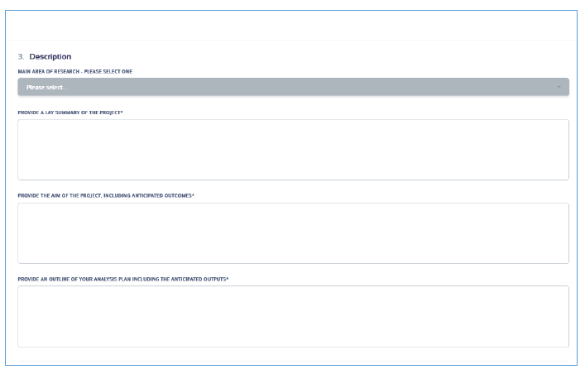
Figure 1: Screenshot of Section 3 in the IGRP application portal.

Dissemination and Impact (Section 4)
Public engagement: Consider the points below in line with the UK Policy Framework for Health and Social Care Research. Research intended to deliver health, and social care benefits should involve patients and the public. Describe any patient and public involvement and engagement (PPIE) activities and demonstrate how the principles of accessibility and public benefit have been considered. You should also outline your plans for disseminating findings to relevant audiences, including patients, the public, and relevant stakeholders (note: publication plans should go in the next question).
Publication plans: Outline how project outputs will be disseminated and how the proposed publication plans will maximise potential impact health and/or social care benefit in England and Wales. Demonstrate how outputs will be shared with appropriate audiences, including researchers, healthcare professionals, policymakers, patients, and the public (where appropriate) – beyond academic audiences. Ensure dissemination activities are aligned with the aims of the project.
Impact plans: In line with the UK Policy Framework for Health and Social Care Research and NHS England Data Access Request Standards, applicants should clearly describe their plans to generate meaningful health and/or social care impact in England and Wales. Include how the research addresses a health or social care challenge, who is expected to benefit from the findings, and how the anticipated outputs may contribute to improvements in policy, clinical practice, patient outcomes, public health, quality of life, or reduction of health inequalities. Explain how they will engage with relevant stakeholders, including patients and the public, healthcare professionals, and policymakers where appropriate, to support the development, relevance, and potential application of the research findings.
Potentially Sensitive Issues (where commercial organisations or partnerships are involved): Applicants should clearly describe both the anticipated public benefit and a transparent account of any anticipated commercial benefit. Describe the nature and scale of the anticipated benefit, how these benefits arise from access to the data, and how they align with public interest.
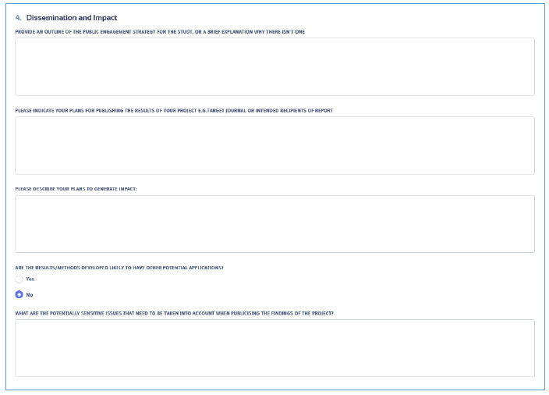
Figure 2: Screenshot of Section 4 in the IGRP application portal.

